Khwopa Engineering College
II sEMESTER ASSESSMENT - 2012 (2069 asoj)
lEVEL:- B. E. (Computer/Elx. & Comm.) I/II
SUBJECT:- BEG123EL, Electrical Engineering
FULL MARKS:- 80
TIME:- 03:00 hrs. 2069-06-23 PASS MARKS:- 32

Candidates are required to give their answers in their own words as far as practicable.
All questions carry equal marks. Figure in the margin indicates full marks.
The marks allocated for each sub-question is specified along its side.
Attempt any FIVE questions.
1. a) Define ideal and practical voltage source. [4]
b) Find the voltage drop between X and Y in the network shown in figure. [5]
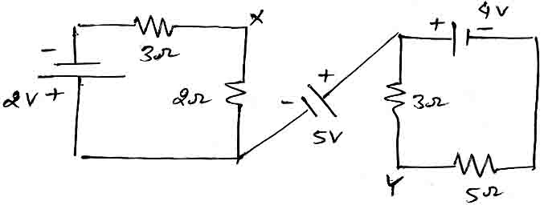
c) Use loop current method to find the current flowing through 3 Ω resistor. [7]
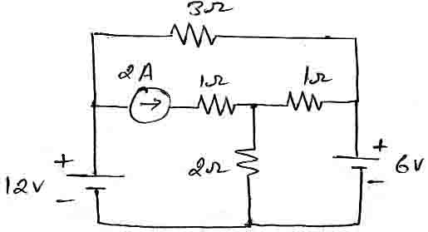
2. a) Using delta-star transformation, find the resistance between terminals A – B in the circuit of given figure. [6]
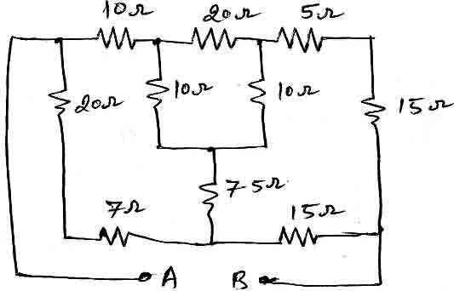
b) Calculate the current flowing through 4 Ω resistor using Thieving's theorem. [6]
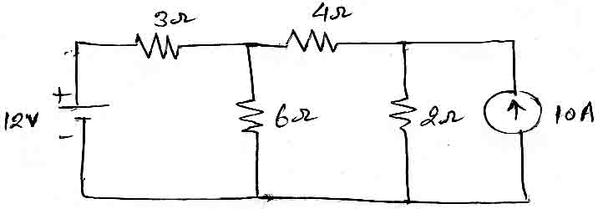
c) Define dependent and independent sources. [4]
3. a) Find the current through 40 Ω resistor using superposition theorem. [6]
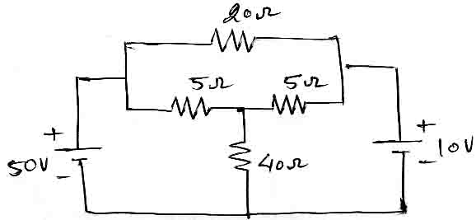
b) Obtain the voltage reduction of the network shown in figure using nodal analysis. [6]
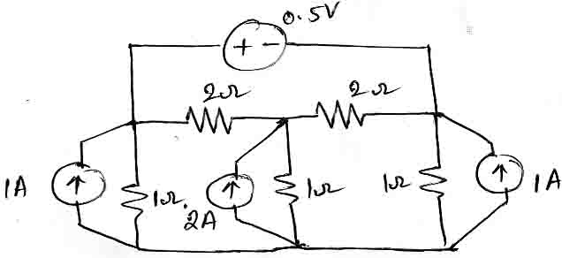
c) State and explain maximum power transfer theorem. [4]
4. a) Prove that the average power dissipated by a pure capacitor when excited by a solenoidal voltage is zero. [6]
b) For the circuit shown below, find [10]
i. Magnitude and phase of I₁ and I₂.
ii. Active and reactive power of path-1
iii. Active and reactive power of path-2
iv. Magnitude and phase of total current I
v. Draw the phasor diagrams showing V, I, I₁ and I₂.
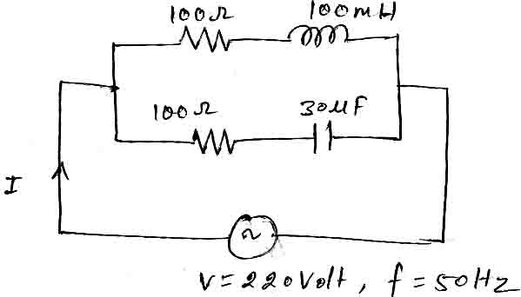

5. a) State Faraday's law of electromagnetic induction. Explain in brief, how alternating emf is generated. [2+4]
b) Find the reading of ammeter when the voltmeter across 3 Ω resistor in the circuit reads 45 V. [6]
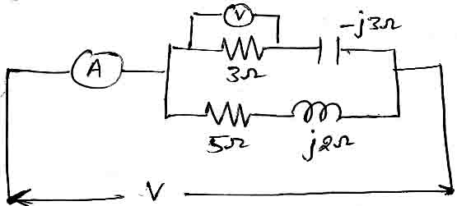
c) A resistance of 45 Ω, inductance of 4 H and capacitance of 25 μF are connected in series across 230 V supply. Calculate: (i) The frequency at which the current will be maximum (ii) The current at this frequency (iii) The potential difference across the inductance. [4]

6. a) Each phase of a star connected load consists of a resistance of 100 Ω in parallel with a capacitance of 32 μF. Calculate the line current, power absorbed, total KVA and the power factor when connected to a 415 V, 3-phase, 50 Hz Supply. [8]

b) Write short notes on (Any TWO): [2×4=8]
i. Relation between line and phase quantities in balanced star connected load.
ii. Tow wattmeter method of power measurement in 3 - φ current.
iii. Power factor improvement.

★

